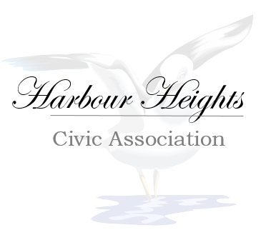 | HHCA Donation Pledge form
Now in existence for over 60 years, the Harbour Heights Civic Association continues to strive to expand its programs and offerings to the community. We hope that you will be able to take part in one or more of the many exciting events that we are offering this year and experience firsthand the pride we take in supporting our cause.
It is our mission to enhance and preserve the quality of life and sense of community through effective and efficient management of the association and support initiatives that benefit the greater good of the community. In order to meet our mission and provide services in our community, we rely on the generosity of individuals and businesses for support. Without the assistance of community-minded individuals just like you, we wouldn’t be able to serve our community each year.
We ask that you make a commitment to support our annual appeal by making a donation and your generosity will make a difference in our community by allowing us to continue in our work.
Remember that every donation makes a difference, regardless of size!
Thank you in advance for your support.
Pledge Information:
I (we) make this contribution of $ __________in the form of: Cash Check Credit Card
Credit Card Type: | Expiration Date _______________________________________________________
Credit Card Number: ____________________________________________________________________
Authorized Signature: ___________________________________________________________________
Please accept this donation to be used in future enhancements of Harbour Heights Civic Association.
I (we) wish to have our gift remain anonymous.
____________________________________________________________________________________
Please make checks payable to: Harbour Heights Civic Association
2530 Harbour Drive
Punta Gorda, FL 33983
Feel free to call us at 941-629-2313 or email us at HHCADOC@GMAIL.COM for information.

